**Planning document**

**Consistency and quality assurance**

We will ensure consistency in our text documents by keeping documents in Arial font with font size 11. Every member of the group will be able to view and suggest changes to each part of the project, which will enforce consistency as one person is not solely doing a part of the project. We have also added a group contract which includes a policy on consistency and uploading to GitLab. We will try to ensure a high quality with planned and scheduled group meetings each week which will allow us to discuss what works well and what does not. Any issues we find will be added to the "Issues" section of GitLab and brought up in group meetings.

API code will follow a consistent format in terms of line spacing, commenting and overall layout. This format is shown here:

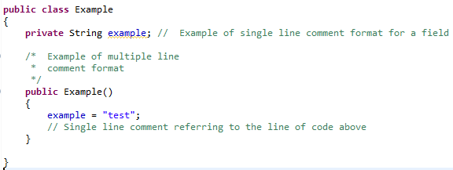

**Version Control**

We will be using Github for all documents within this project. Github supports papyrus and word documents alike. Group members will access documents directly from Github, rather than from their own storage space, which will ensure they are always working on the most current version. Each document will be saved to Github at the end of each meeting. Github will allow us to set specific deadlines for each document, which is perfect for projects such as this with multiple stages.

**Reviews**

We will have a meeting to review submitted work after each of the five stages. In these meetings we will look at the submitted work, and discuss what we could do to improve. This can then be implemented for the next stage of the project. We will compare planned progression against the progress we have actually made.

**Software Testing**

Once coding has started we will constantly be running unit tests against core functionality. These will be created as the code is developed. When the code completes all unit tests and appears functional we will perform manual testing against use case scenarios. Any bugs or errors found during testing will be flagged as an issue on the GitHub project and brought up in a group meeting.